Technical Design Document

For ETA: All The Counters

Document Authors
Aidan Mckeown - Team Lead and Programmer
Sean Volders - Executive Programmer

Table of Contents
- Introduction
- Platforms
- Target Platforms
- Technical Specifiactions
- Asset Specifications
- Timeline
- Diagrams and Tables

1: Introduction
ETA: All The Counters, is a fast paced action fighting game where only skill matters and the blocks don’t exist. The key difference between this game and most generic fighting games is the simple fact that the only attack is a ranged attack, there are no combos, and to not take damage you must either dodge or counter this attack. There is no block mechanic.

The Team:
Designer
- Nathan Mell

Programmers
- Aidan Mckeown
- Sean Volders

Artists
- Harry Vernon
- Anderson Nguyen
- Lochlan Cook

2: Platforms

  - Target Platform
Eta will be targeted for the PS3, PS4 , Xbox360 and Xbox One.
There will also be a PC port, however the controls are not designed for anything but controller input.
  - Technical Specifications
We will be building for the lowest common denominator in terms of performance capabilities. With the lowest CPU and GPU performance, we will be aiming for high frame rates on an Xbox360, with the specs being equivalent roughly to a PC as follows.
MIN specs
CPU: Skylake i3 – 6100
GPU: Radeon 7770
RAM: 2gb DDR3 at 800Mhz
HDD: 256gb HDD
Memory required for install: ~250MB

3: Assets Specifications

Character Data
  - 4 Character models
  - 2 specialised projectiles for each character
  - Any assets needed on a per individual basis for special attacks
Sounds/ Music: files will be in .WAV format
  - Counter/ hit sounds
  - Walking/ dashing/ stepping sounds
  - Gameplay Music
  - Voice files for each character for : Attacking, getting hit, jumping
Level data:
  - 1 Level made of basic assets per character that fits each characters individual theme

4: Diagrams and Tables
Game State flow chart:
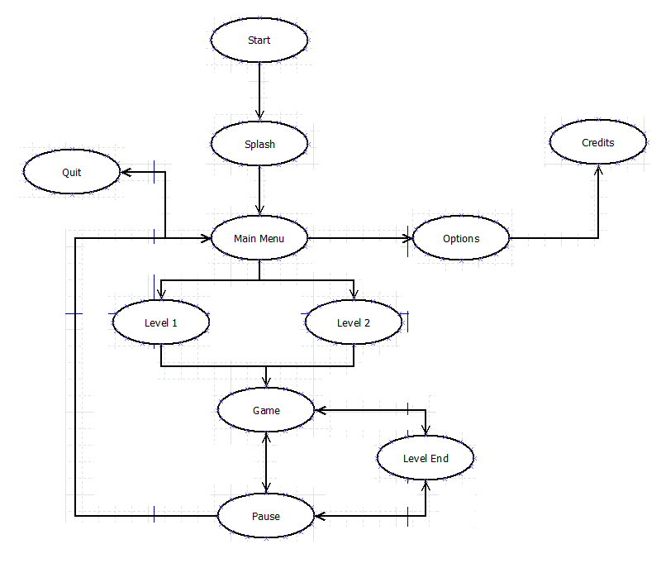

Scripts:
Script | Description
ArrowMovement | Controlls the projectiles that are fired by the player
AudioScript | Manages the sound, running when sound is required.
CameraPos | Controls the camera as it lerps around following the players
EdgeDetection | Gives the Bold Outlines to shapes to give the cool shaded look
GameController | Handles Global Variables
HealthBarScript /  SpecialBarScript | Controls the UI health and special bar dependant on player health and special values
PauseScript | Pauses the game and shows menu UI
PlayerController | Handles all player movement and firing mechanics
SpecialBase | A parent script which all special scripts should derive from
Special Scripts  for Each Character | A script for each character that makes them do their own specific special attack, derived from the SpecialBase script so it can be handled by all parties.

5: Timeline

Week | Description
1. Concept Visualisation | Put together details about our game with initial concept art and approval
2. Alpha Build | Started creating our games, getting the core mechanics of the game down and have it playable
3. Alpha Build
4. Alpha Build
5. Alpha Build
6. Beta Build | Began adding extra features to the game and fixing up any problems from alpha
7. Beta Build
8. Beta Build
9. Gold Build | Polished the game and preparing it to run on the VITA and PlayStation 4
10. Gold Build
11. Gold Build
12. Post Mortem | Complete all post-production documentation

